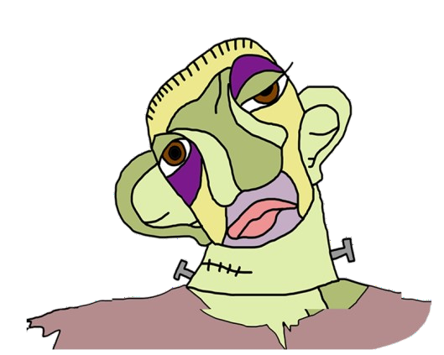MONSTERS

|  |  |  |  |
| --- | --- | --- | --- |
|  | **THE MONSTER**  **OF VICTOR FRANKENSTEIN** | **QUASIMODO** | **THE ELEPHANT MAN** |
| **REAL PERSON OR CHARACTER ?** | Character | Character | Real person |
| **WHO CREATED HIM?** | Mary Shelley | Victor Hugo | Frederick Treves Ashley Montagu. |
| **WHEN ?** | 1818 | 1831 | 1862 |
| **BOOK HE BELONGS TO** | Frankenstein | The Hunchback of Notre Dam | The true story of the Elephant man. |
| **HIS PROBLEM** | Victor has the inability to understand that this actions have repercussions. | He has a hump and nobody likes him. | He had the Potreus syndrome, a bizarre condition in which a mutant gene causes asymmetrical growth on body parts. |
| **COULD HE BE HAPPY?** | No, because most of his time he feels alone and betrayed. | At the end of the book yes because he found someone that loved him. | No, because his mom died. |
| **HOW DID HIS LIFE END?** | He killed himself because he felt bad about all the things that he did. | Quasimodo is finally accepted into society. | He died of a dislocated neck. |